STN LCD Hall Coulombmeter current voltage power meter instructions
First, the function introduced
1. Measure the percentage of battery charge remaining (indicated by the number of battery icon bars) and the number of remaining battery AH.
2. Measure the DC positive and negative bidirectional current.
3. Measure the DC voltage.
4. Measure the DC positive and negative power.
5. Measure the cumulative energy in both positive and negative DC directions.
6. Overvoltage alarm flashing function, alarm voltage size parameters can be set by themselves.
7. Low-voltage alarm flashing function, the alarm voltage size parameter can be set by itself.
8. Overcurrent alarm flashing function, alarm current size parameter can be set by itself.
9. The remaining battery low alarm flashes and the battery icon flashes continuously, prompting the user to charge.
10. When the battery is charging, the battery icon scrolls through the water.
11. The full voltage automatically fills up the battery capacity.
12. Clear the current function.
13. Clear the cumulative energy function.
14. The backlight can be turned off or on manually.
15. Power-down data saving function, when the power is off, the battery power, accumulated power and so on are automatically saved after power-off.
16. The use of Hall sensor isolation measurement, safe and reliable, easy installation.
17. Using STN full-angle LCD screen, 360 degrees without dead ends. With backlight, no matter night, daytime, indoors, room
Outside, direct sunlight is clearly visible.
- Ultra-wide supply voltage range: DC5~90V

Second, install and use simple steps
1. First connect. The correct wiring is a coulomb meter showing positive current during discharge and charging showing negative current. If it is not the case that your sensor is reversed, you can reverse the sensor.
2. Set the parameters. It is necessary to set both the battery rated capacity AH and the fully charged automatic full voltage FU. If a new coulomb meter is installed, if the current is not zero at no load, it is also necessary to clear the current under no load.
3. After the cable is connected and the parameters are set, the battery capacity will not be immediately displayed on the meter. At this time, the battery icon and capacity are still empty. It is also necessary to fully charge the battery to display the remaining battery capacity. This requires special attention.
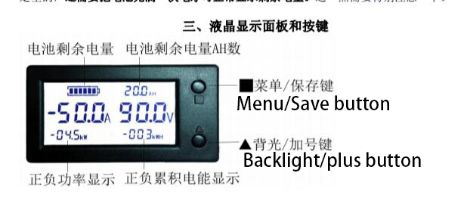

Fourth, the use of keys
1. Backlight control:
In the standby display, short press the ▲ key to turn the screen backlight on or off, and the backlight status is automatically saved when the power is off.
2. Clear the current:
In the standby display, when the load is no load, long press the ▲ key to clear the current zero point. If no load
If the current is not 0, this method can be used to clear the current zero. (Note: Must be cleared at no load,
Otherwise it will not be accurate. ) Empty load is when neither charging nor discharging.
3. Clear energy:
In the standby display, press and hold the █ key and release the key to clear both positive and negative currents in both directions at the same time.
Positive and negative energy.
4. Set the parameters: (Note: The parameters of menu【1】【2】 must be set, other see your needs)
In the standby display, short press █ to toggle the menus in order:
[1] "AH XXX.X" battery rated capacity setting menu. This parameter must be set. This one
The parameter is set to the size of your battery's rated capacity.
[2] "FU XXX.X" is fully charged automatically to increase the voltage size setting menu. When the voltage reaches this value,
The coulometer's power level is automatically filled to the correct 100% full charge. This parameter is recommended to set because the battery charge
Discharge efficiency is inconsistent. If it is not set, the parameter will be accumulated after multiple charge and discharge errors.
[3] "HU XXX.X" overvoltage alarm voltage setting menu
[4] "LU XXX.X" Low Voltage Alarm Voltage Setting Menu
[5] "HA XXX.X" Over current alarm current setting menu
The method for setting the rated capacity of the battery: (1) In standby, short press █ key to switch to the menu "AH XXX.X",
(2) The first digit of the menu parameter will continue to flash. At this time, press the ▲ key to increase the number by one.
After setting this number, the 5S clock will not operate the button, it will automatically jump to the next digit flashing, this time
Also press the ▲ key for a short time. This number will also increase by one. If the button is not operated within 5 seconds, it will automatically jump to the next digit flash.
Scroll to set the next digit. This will be followed by analogy after setting up 4 digits.
(3) Press and hold the █ key (note: long press is not short press) and release the key to save the set parameters.
At this time the menu will flash twice to prompt the user to save successfully.
For example: To set the battery's rated capacity to 20AH, set this menu parameter to AH 020.0.
After you press and hold the █ key and release it, you can save it.
Fully automatic full-fill voltage setting method: Same as above (1) In standby, short press █ key,
Switch to menu "FU XXX.X", short press ▲ key to set parameters, long press █ key to save the settings
Set the parameters. (Note: This voltage is recommended to be set to a value less than the power of the charger after the battery is fully charged.
The Coulomb meter shows a low voltage of 0.3V. )
Then set the overpressure alarm voltage value, low voltage alarm voltage value, and overcurrent alarm current value in turn.
(Note: If these three parameters HU XXX.X LU XXX.X HA XXX.X are set to 000.0, it means that
Turn off the alarm flash feature of this item. The factory default is off. )

Model WLS-PVA050 WLS-PVA100 WLS-PVA200 WLS-PVA400
Current measurement range 50A 100A 200A 400A
Current resolution 0.1A 0.1A 0.2A 0.2A
Supply voltage range DC5～90V
Voltage measurement range DC0~300V
Voltage resolution 0.1V
Capacity measurement range 0～999AH
Power measurement range 0～999KW
Electric energy measurement range 0～999KWH
Table measurement error + -1%
Refresh rate 0.5S refresh display information
Mounting slot size 76.0mm * 39.5mm
Sensor thread hole diameter Φ20mm
Operating current When the backlight is lit: 10MA. When the backlight is off: 4MA.

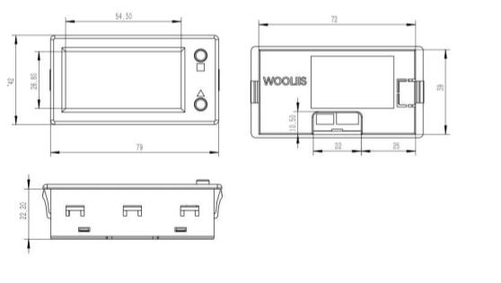

Seven, wiring instructions
The LCD Hall Coulomb meter is designed with an ultra-wide supply voltage. The meter adopts a three-wire design and the voltage measurement range can be more
broad. If the measured voltage is in the range of DC 5~90V, it can be connected to two-wire connection mode, providing more flexible and convenient power supply.
There are a total of three wires on the back of the header, as shown below:
[1] The black wire is connected to the negative pole of the power supply.
[2] The red wire is connected to the positive pole of the power supply (Note: The voltage range of the power supply is DC 5~90V. Do not overpressure, otherwise burn the meter).
[3] The yellow wire is connected to the voltage measurement input lead and needs to be connected to the measured voltage lead.

When the measured voltage is DC 5 to 90V, the two-wire system shown below can be used to connect the red and yellow wires of the meter in parallel to the positive electrode of the battery. As follows:
Note: Attention should be paid to heat dissipation and ventilation when the power supply voltage is greater than 80V. When more than 80V, it is recommended to supply power separately

When the range of measured voltage exceeds DC 5~90V, three-wire connection method must be adopted, and another power supply (Note: This power supply and the measured power supply must share the ground) to supply power to the meter. As shown below: General electric vehicle controller also has a 12V or 5V power output, you can also use this power supply.
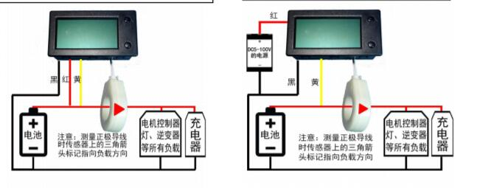
The above wiring diagram is the connection mode of the charge and discharge ports. If the discharge and charge of the battery are different, then the power lines of the discharge positive electrode and the charging positive electrode should pass through the hole in the middle of the sensor. If for any other reason the charge current cannot be measured, then it does not matter, and then we can use the coulomb meter's full charge to automatically reset the power to 100% full charge function, just so that each charge should be full and the charging process cannot see the charge current There will be no running lights, and electricity will not increase slowly. Fully charged is reset to 100% power.
The above figure is to measure the battery positive main line, you can also measure the battery negative main line, when measuring the negative main line, just pay attention to the sensor's direction mark points to the battery in that direction, and the measurement of the positive main line is pointing to the direction of the load.
Eight, use precautions
1. The correct wiring of the sensor is: Coulomb meter shows positive current when discharging, and negative current when charging. If it is not that you pass
The sensor is reversed. You can reverse the sensor.
2. If the table shows only the positive current of the discharge after the line is connected and the charge does not show a negative current, then the current you are charging is not
With sensors, you need to check if your sensor is measuring accurately. It is recommended that the sensor measure the position of the battery
All the main wires of the positive electrode of the group, or all the main wires of the negative electrode.
3. Note: The coulometer meter and the sensor are not waterproof and cannot enter the water. The influent water must be burned.

