▼ Product Features:
● Dual channel pulse signal output,90degree phase difference, can detect rotary speed and direction.
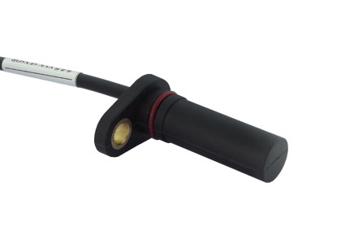
● Built-in polarity and short circuit protection.
● Wide temperature range.
- Good EMC anti-interference ability.
- High IPgrade:IP67.
- Mainly used in electric tour car, electric golf carts, electric forklifts and other fields.
▼ Parameters and specifications:
Character | Parameter Values | Instruction
Fixing gap | 0~2mm,typical fix gap 1mm | When the rotary frequency is high, the installation clearance shall be as small as possible.
Target tooth width | 2 mm±0.1 mm | Tooth module m=1.25, Iron Gear
Target groove width | 2 mm±0.1 mm | Tooth module m=1.25, Iron Gear
Tooth depth | >3mm | Tooth module m=1.25, Iron Gear
Tooth width | >8mm | Tooth module m=1.25, Iron Gear
Working temperature | -40~140℃ | Continue operating temperature
Service voltage | DC4.5~24V; DC10~30V
Max reverse voltage | 60VDC
Operating current | 16mA
Load current | <80mA
Signal output form | square wave, collector, open collector | 90°phase difference between two signal A and B channels.  when open collector output, the inner pull-up resistor is 5KΩ
AB phase-difference | 90±20° | Tooth module m=1.25
Output high Level | >(VCC-0.5V)
Output low level | <0.5V
Response frequency | 1~20KHz
Signal rise time | <10us
Signal fall edge time | <1us
IP grade | IP67 | Can be operated in liquid environment
Connecting form | 4 wires /AMP | 4 wires: Yellow-VCC, Blue-A, White-B, Black-GND

▼ Electrical Connection：
When do the no load test, the A pulse and B pulse must series 5K resistance separately with VCC.

▼ Output Signal：
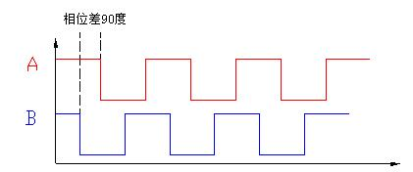
When pulse wheel is rotated forward, A pulse will advance B pulse 90degree.。
When pulse wheel is rotated backward, B pulse will advance A pulse 90degree.

▼ Test Method (unit: mm):
The best target gear tooth:
- The material: Magnetic conductivity metal materials
2、 Size：tooth width:2mm, tooth space width: 2mm, tooth high: 5mm

